NLP BASED AUTONOMOUS RESEARCH ASSISTANT
PROJECT REPORT PHASE I
Submitted in partial fulfilment of the requirements of
the
Award of the degree of
BACHELOR OF TECHNOLOGY
In
ARTIFICIAL INTELLIGENCE AND DATA SCIENCE

Submitted By Under the Supervision of
Harshit Gupta (22EMCAD015) Dr. J.R. Arun Kumar
Meet Singh (22EMCAD026) Professor
Dhruv Mukhija (22EMCAD008) Head of Department
Sahibdeep Singh (22EMCAD050) Dept. of CSE & AI




BIKANER TECHNICAL UNIVERSITY, BIKANER
MODERN INSTITUTE OF TECHNOLOGY AND RESEARCH CENTRE
ALWAR
NOVEMBER, 2025
(2025-26)

BIKANER TECHNICAL UNIVERSITY, BIKANER
CERTIFICATE

This is to Certify that the project report entitled “NLP BASED AUTONOMOUS RESEARCH ASSISTANT” is the original & genuine work of “HARSHIT GUPTA, MEET SINGH, DHRUV MUKHIJA, SAHIBDEEP SINGH”, student(s) of B. Tech VII Semester (Artificial Intelligence & Data Science Branch) who carried out the project work under my supervision & guidance.

SIGNATURE  Dr. J.R. Arun Kumar  HEAD OF THE DEPARTMENT  Dept. of CSE & AI | SIGNATURE  Dr. J.R. Arun Kumar  Professor  Head of Department  Dept. of CSE & AI

ACKNOWLEDGEMENT

Firstly, we express our sincere thanks to Prof. Dr. S. K. Sharma, Director of the Modern Institute of Technology & Research Centre, Alwar, Rajasthan, for his continuous support and encouragement.
We also extend our deep sense of gratitude to Dr. J. R. Arun Kumar, Head of the Computer Science & Engineering Department, Modern Institute of Technology & Research Centre, Alwar, for motivating us to reach higher levels and providing us with the valuable opportunity to present this project.
We owe our heartfelt thanks and sincere gratitude to our project guide, Dr. J.R. Arun Kumar Assistant Professor, Department of Computer Science & Engineering, Modern Institute of Technology & Research Centre, Alwar, for his invaluable guidance, insightful suggestions, constant supervision, and encouragement throughout the completion of this work.
We would also like to thank our Institute and all Faculty Members whose support and cooperation made this project possible. We extend our warm thanks to our families and well-wishers for their continuous support and encouragement.
Finally, but most importantly, we express our profound gratitude to our parents for their unconditional love, patience, and inspiration throughout our academic journey.

Harshit Gupta (22EMCAD015)
Meet Singh (22EMCAD026)
Dhruv Mukhija (22EMCAD008)
Sahibdeep Singh (22EMCAD050)

TABLE OF CONTENTS

TOPICS PAGE NO
CERTIFICATE………………………………………...................................................................i
ACKNOWLEDGEMENT……………………………………………………….........................ii
TABLE OF CONTENTS………………………………………………………………………. iii
LIST OF FIGURES........................................................................................................................iv
ABSTRACT....................................................................................................................................v
CHAPTER 1: INTRODUCTION 1
1.1 What Is NLP Based Autonomous Research Assistant 1
CHAPTER 2: PROBLEM STATEMENT 2-5
CHAPTER 3: LITERATURE REVIEW 6-12
CHAPTER 4: SYSTEM DESIGN 13-23
4.1UML DIAGRAMS
4.1.1 Use Case diagram
4.1.2 Activity diagram
4.1.3 Sequence diagram
4.1.4 Class diagram
4.1.5 Component diagram
4.1.6 Deployment diagram
4.1.7 Communication diagram
4.1.8 Object diagram
CHAPTER 6: PROPOSED WORK MODEL 23-28
CHAPTER 7: SCREENSHOTS 29-30
CHAPTER 8: TECHNOLOGY STACK 31-37
CHAPTER 9: FUTURE WORK 38-43
REFERENCES 44

LIST OF FIGURES

Figure4.1.1 Use Case Diagram……………………………......................................................16
Figure4.1.2 Activity Diagram……..………………………......................................................17
Figure4.1.3 Sequence Diagram……………………………......................................................18
Figure4.1.4 Class Diagram…………...……………………......................................................19
Figure4.1.5 Component Diagram…….……………………......................................................20
Figure4.1.6 Deployment Diagram…………………………......................................................21
Figure4.1.7 Communication Diagram…..…………………......................................................22
Figure4.1.8 Object Diagram………….…….………………......................................................23
Figure 5.1 Proposed Work Model……..…………………….....................................................24
Figure 6.1 Dashboard………….……....…………………….....................................................29
Figure 6.2 HomePage…………….…....…………………….....................................................30

ABSTRACT
The rapid growth of scientific literature has created a significant challenge for researchers who must analyze, interpret, and synthesize large volumes of information within limited timeframes. Traditional manual research methods are slow, error-prone, and often insufficient for identifying hidden insights, research gaps, and relevant citations. Recent advancements in Natural Language Processing (NLP), Large Language Models (LLMs), and Retrieval-Augmented Generation (RAG) provide an opportunity to automate and accelerate the research workflow.
This project presents an NLP-Based Autonomous Research Assistant, a system designed to support researchers by automating literature analysis, summarization, question answering, and metadata extraction. The system enables users to upload research documents, extract meaningful chunks, generate vector embeddings, identify top-K relevant segments, and produce context-based answers with accurate citations. It integrates key technologies such as FastAPI for backend services, a React-based frontend interface, Chroma DB for vector storage, MongoDB for metadata storage, and an LLM service for generating high-quality responses.
The proposed solution includes multiple components—document ingestion, embedding generation, semantic retrieval, autonomous gap analysis, dashboard visualization, and AI-supported summaries. Through a combination of advanced NLP algorithms and structured workflow automation, the system helps researchers reduce time spent on literature review, improve citation accuracy, and quickly identify knowledge gaps.
Overall, the NLP-Based Autonomous Research Assistant enhances productivity and supports intelligent decision-making in academic research. It demonstrates how AI-driven automation can transform the research lifecycle by providing fast, reliable, and context-aware insights. The system represents a scalable solution with potential applications in academic institutions, research laboratories, and data-driven industries.

CHAPTER 1
INTRODUCTION

1.1 What Is an NLP-Based Autonomous Research Assistant
The rapid expansion of digital information has transformed the way research is conducted across academic, industrial, and scientific domains. Every year, millions of research papers, articles, and technical documents are published, making it increasingly difficult for students, researchers, and professionals to stay updated with the latest developments. Traditional research methods—such as manually searching, reading, and summarizing literature—are slow, time-consuming, and often mentally exhausting. As a result, individuals frequently struggle to extract meaningful insights, evaluate relevant work, or identify research gaps within limited time constraints.
With recent advancements in Artificial Intelligence (AI), especially in Natural Language Processing (NLP) and Large Language Models (LLMs), automated research assistance has become not just possible but highly effective. AI systems are now capable of understanding context, summarizing long documents, detecting semantic relationships, generating insights, and answering complex questions with high accuracy. These capabilities can significantly enhance the research workflow by reducing manual effort and improving the quality of academic output.
This project, NLP-Based Autonomous Research Assistant, aims to bridge the gap between the growing volume of scientific literature and the limited time researchers have to analyze it. The system utilizes a combination of advanced NLP techniques, vector embeddings, semantic search, and Retrieval-Augmented Generation (RAG) to create an intelligent research companion. Users can upload research papers in PDF or text format, after which the system extracts text, divides it into meaningful chunks, generates embeddings, stores them in a vector database, and retrieves relevant information based on user queries. The LLM then processes this information to produce accurate, context-aware responses with proper citations.

CHAPTER 2
PROBLEM STATEMENT
The modern research landscape is undergoing a dramatic transformation driven by exponential growth in digital information. Every field—computer science, engineering, medicine, social sciences, and humanities—produces massive amounts of scholarly work daily. Academic repositories, digital libraries, and open-access platforms host millions of publications that continue to grow at an overwhelming pace. While accessibility of research has improved, the ability to process, understand, and extract meaningful knowledge from these vast datasets has become increasingly challenging. Researchers, students, analysts, and industry professionals are struggling to keep up with the volume, complexity, and speed of new information being generated.
Traditional methods of conducting research, such as manually reading papers, highlighting important points, comparing different studies, identifying gaps, and summarizing findings, have become highly inefficient. A single research paper may span 10 to 20 pages, often containing dense technical language, complex figures, mathematical formulations, and domain-specific terminology. For comprehensive surveys or project work, researchers often need to read dozens, sometimes hundreds, of such papers. This process can take days or even weeks, significantly slowing down productivity. Beginners, in particular, find it extremely difficult to understand and synthesize information due to lack of familiarity with research methodologies and academic writing styles.
Even experienced researchers face difficulties. Research papers often differ in structure, language style, and organization. Important insights may be hidden inside long discussions, appendices, or technical explanations. Finding relevant information becomes like searching for a needle in a haystack. The challenge is not only the quantity but also the quality and relevance of information. Researchers frequently encounter papers that are outdated, duplicated, or unrelated to their current work, further complicating the filtering and analysis process.
Existing tools provide only partial solutions. Standard keyword-based search engines can retrieve documents but fail to understand context, meaning, or semantic relationships. Summarization tools offer brief overviews but often miss critical details, technical insights, or citation relationships. Reference managers help organize papers but do not assist in understanding them. There is currently no integrated system capable of performing intelligent, context-aware, and autonomous research assistance from end to end.
A major limitation of traditional search systems is their dependency on keywords. Academic content often uses diverse terminology; similar concepts may be described using different names, which keyword search fails to capture. Unlike humans, these systems lack semantic understanding and cannot connect “related work” across multiple papers. As a result, important studies are missed, and literature reviews become incomplete. This leads to poor analysis, weak arguments, and inaccurate interpretations in academic writing.
Moreover, researchers often need answers to very specific questions, such as:
- “What methodology is used in this study?”
- “What dataset is utilized in similar experiments?”
- “What are the limitations or future research gaps?”
- “Which papers support or contradict this hypothesis?”
Manually searching for these answers may require reading multiple papers in detail. Without an automated system capable of retrieving and summarizing information from various sources, this task becomes extremely time-consuming.
Another critical problem is the difficulty in identifying research gaps. While most researchers can read and understand papers, detecting what hasn’t been done—what is missing, unexplored, or insufficiently studied—requires significant experience and time. This gap identification is essential for choosing strong research topics, writing meaningful project reports, and contributing original ideas. Current tools do not assist in this area at all.
Additionally, research today demands accuracy and proper citations. When answering a question or summarizing a concept, it is crucial to reference the correct source. Many automated tools generate generic content without linking it back to the original documents, leading to credibility issues. For academic submissions, thesis reports, and professional projects, citation-based answers are essential. Yet, most existing AI tools cannot provide citations, traceable sources, or verifiable evidence linked to user-uploaded documents.
The absence of an integrated, intelligent, and autonomous research assistant causes several issues:
- Excessive Time Consumption
Researchers spend long hours reading, organizing, and analysing papers. This delays project development and reduces overall efficiency.
- Low Productivity
Repetitive tasks such as summarizing, extracting definitions, or comparing methods consume energy that could be used for critical thinking and creativity.
- Incomplete Understanding
Important details may be missed, leading to incomplete reports or weak literature reviews.
- Difficulty for Beginners
Students new to research struggle the most due to lack of domain knowledge and experience with academic language.
- Limited Access to Insights
Manually interpreting large text documents restricts deeper insights that AI-based systems could extract from complex patterns.
- Poor Decision-Making
Without quick access to relevant information, researchers may choose irrelevant topics, outdated methodologies, or unsuitable datasets.
- Lack of Automation
There are no systems that automate the entire cycle of document processing, retrieving, summarizing, visualizing, and answering queries.
Given these significant challenges, there is a clear and urgent need for an AI-driven solution that can transform the research experience. The system should not only retrieve papers but understand them semantically. It should break down documents into meaningful components, convert them into embeddings, store them efficiently, and retrieve relevant sections when required. It must provide accurate, context-dependent answers along with citations from the exact document source. Additionally, the system should be capable of generating summaries, analyzing content, highlighting key concepts, identifying research gaps, and presenting findings in visually structured dashboards.
The NLP-Based Autonomous Research Assistant proposed in this project aims to fill this gap. Using cutting-edge technologies such as Natural Language Processing, Large Language Models, Retrieval-Augmented Generation, vector databases, semantic search, and AI-driven document analysis, the system automates critical research tasks. It reduces the manual burden, increases productivity, and ensures accuracy. The assistant helps users understand complex academic material quickly, discover insights that might otherwise be overlooked, and develop high-quality research reports in significantly less time.
In essence, the problem this project addresses is the lack of an intelligent, automated, and semantically aware system that can support and enhance the research process end-to-end. By solving this problem, the proposed system empowers students, researchers, professionals, and institutions to work more efficiently, think more critically, and produce better academic outcomes in a world of exponentially expanding information.

CHAPTER 3
LITERATURE REVIEW
The field of Natural Language Processing (NLP) has witnessed rapid advancements in recent years, driven primarily by the availability of large datasets, powerful computational resources, and breakthroughs in deep learning architectures. These developments have transformed how textual information is processed, retrieved, summarized, and understood by machines. In the context of academic research, NLP-based systems have become increasingly valuable due to their ability to automate complex tasks like summarization, semantic search, information extraction, and document understanding.
This literature review examines the key technological foundations, related works, existing methodologies, and research gaps relevant to the development of an NLP-Based Autonomous Research Assistant. It also provides an overview of major contributions in areas such as document retrieval, vector embeddings, semantic search, large language models (LLMs), and Retrieval-Augmented Generation (RAG). The review is organized into multiple sub-sections to thoroughly analyze how prior studies have shaped the need and framework of the proposed system.

3.1 Evolution of NLP in Research Automation
Early NLP systems relied heavily on rule-based approaches. These systems followed predefined linguistic patterns to interpret text but lacked flexibility and scalability. As research domains expanded, rule-based systems struggled to handle complex grammar, ambiguous language, and the vast variety of academic writing styles.
The introduction of statistical NLP (such as Hidden Markov Models, Naive Bayes, and basic n-gram language models) improved contextual understanding but still fell short in grasping semantic meaning. The shift towards deep learning-based models, especially the emergence of recurrent neural networks (RNNs) and long short-term memory networks (LSTMs), pushed NLP capabilities forward by enabling better context retention in longer texts.
However, it was the introduction of the Transformer architecture by Vaswani et al. (2017) that revolutionized the NLP landscape. The concept of self-attention allowed models to understand relationships across entire documents, enabling a dramatic leap in tasks related to text comprehension and generation. This architecture led to models such as BERT, GPT, XLNet, RoBERTa, T5, and many others—each contributing significantly to advancements in research automation.
These evolutions collectively formed the foundation of intelligent research assistants capable of understanding and generating human-like text.

3.2 Document Retrieval and Search Algorithms: From Keyword to Semantic Search
Traditional document retrieval systems relied on keyword-based search techniques. Early search engines used TF-IDF (Term Frequency–Inverse Document Frequency) and BM25 ranking algorithms, which focused on matching exact words or phrases. Although effective for simple queries, these methods failed to understand the deeper context of academic content.
For example, a user searching for “neural text summarization methods” might miss papers that use different terminology like “sequence-to-sequence learning” or “encoder-decoder networks”. Keyword systems cannot capture semantic similarity or contextual meaning.
To overcome these limitations, researchers began exploring semantic search, which relies on vector representations of text (embeddings). Significant progress occurred with the development of models such as:
- Word2Vec (Mikolov et al.) — captured word-level similarity
- GloVe — emphasized global co-occurrence patterns
- FastText — improved subword embeddings
- Sentence-BERT (SBERT) — enabled sentence- and paragraph-level similarity
- Universal Sentence Encoder — simplified semantic comparison
- OpenAI Embedding Models — advanced contextual vectorization
Semantic search transformed document retrieval by allowing systems to understand meaning rather than keywords. This shift is central to the functioning of the proposed research assistant, which relies on high-quality embeddings and vector databases to retrieve relevant content.

3.3 Vector Databases and Embedding-Based Retrieval
The rising importance of embeddings created a need for dedicated systems to store, index, and query high-dimensional vectors efficiently. Traditional relational databases are not optimized for similarity search, so new technologies emerged—known as vector databases.
Prominent examples include:
- Chroma DB
- FAISS (Facebook AI Similarity Search)
- Pinecone
- Weaviate
- Milvus
These databases enable quick retrieval of semantically similar chunks based on cosine similarity, dot product, or Euclidean distance.
The ability to store document chunks as embeddings and retrieve the most relevant ones forms the backbone of Retrieval-Augmented Generation (RAG). Systems built on these technologies significantly outperform keyword-based retrieval methods in complex academic tasks.

3.4 Advances in Text Summarization Techniques
Text summarization is crucial for research automation. Over time, summarization evolved through multiple stages:

3.4.1 Extractive Summarization
Earlier approaches extracted important lines without modifying the text. Techniques included:
- LexRank
- TextRank
- TF-IDF-based ranking
- Sentence scoring based on frequency and position
While these methods were relatively simple, they struggled with coherence and contextual relevance. Summaries felt fragmented and incomplete.

3.4.2 Abstractive Summarization
Deep learning enabled systems to generate summaries in natural language rather than simply extracting sentences. Models like:
- Seq2Seq with Attention
- Pointer-Generator Networks
- Transformer-based summarizers
- T5 (Text-to-Text Transfer Transformer)
- GPT models
allowed more meaningful, coherent, and human-like summaries.
These advancements laid the foundation for autonomous systems capable of summarizing large documents, identifying key points, and simplifying technical content for users.

3.5 Rise of Large Language Models (LLMs) and Their Influence on Research Automation
The introduction of large-scale pre-trained transformers like GPT-3, GPT-4, PaLM, LLaMA, and Falcon unlocked unprecedented capabilities in natural language understanding and generation. LLMs can:
- Understand long, complex research documents
- Answer contextual questions
- Generate structured explanations
- Produce coherent summaries
- Identify relationships between concepts
- Infer missing information
- Assist with research gap identification
Several research studies demonstrated how LLMs could support research in multiple domains, including healthcare analysis, legal document understanding, software engineering documentation, and academic paper summarization.
These models made it possible to build intelligent research assistants that behave similarly to human experts, but at significantly faster speeds.

3.6 Retrieval-Augmented Generation (RAG): The Backbone of Modern Research Assistants
A major breakthrough in the field was the development of RAG frameworks, which combine retrieval systems with language models. Traditional LLMs are powerful but may generate hallucinations if not grounded in source data. RAG addresses this by retrieving relevant information first and then generating answers based on retrieved content.
Key studies and implementations include:
- RAG by Facebook AI (2020)
- DSI (Differentiable Search Index)
- ColBERT
- OpenAI's new embedding + retrieval pipelines
RAG has proven to substantially improve the accuracy, reliability, and factual grounding of automated research systems.
Modern RAG systems allow:
- Context-aware question answering
- Citation-backed responses
- Deep analysis across multiple documents
- Reduced hallucinations
- Efficient summarization aligned with actual source content
The proposed research assistant relies extensively on RAG to provide accurate, verifiable insights based on uploaded documents.

3.7 Autonomous Research Systems: Existing Tools and Limitations
A number of research tools exist today, but each has significant limitations that justify the need for your proposed system.

3.7.1 Google Scholar
Provides access to research papers but cannot summarize, analyze, or answer questions.

3.7.2 Semantic Scholar
Uses AI-based indexing but offers limited summarization or contextual answers.

3.7.3 ResearchRabbit, Connected Papers
Help visualize citations but do not analyze content in-depth.

3.7.4 Scite.ai
Evaluates citation intent but lacks advanced Q&A or gap detection.

3.7.5 GPT-based tools
General-purpose AI with no grounding in user-uploaded documents unless custom RAG pipelines are used.
Across all existing systems, the missing capabilities include:
- Deep semantic retrieval
- Accurate citation-based responses
- Autonomous gap detection
- Complete literature analysis
- Dashboard visualization
- End-to-end research workflow automation
This gap highlights the need for a more robust, customized, and domain-agnostic research assistant.

3.8 Gap in Literature
Through examination of prior works, several gaps become evident:
- Lack of systems that combine NLP, vector search, RAG, and autonomous analysis in a single workflow
- Limited capability for citation-based Q&A grounded strictly in user documents
- Absence of intelligent tools to identify research gaps automatically
- Inability of existing systems to process multiple documents and integrate insights across them
- Lack of dashboards or structural analysis for visual understanding
- Minimal support for end-to-end academic research assistance
- No specialized solutions tailored for students, beginners, or small research teams
These gaps directly motivate the need for the proposed NLP-Based Autonomous Research Assistant.
CHAPTER 4
SYSTEM DESIGN
System design defines how all components of the NLP-Based Autonomous Research Assistant work together to process documents, extract information, and generate intelligent responses. The goal of the design is to create a modular, scalable, and efficient architecture that can handle academic papers, perform semantic retrieval, and generate accurate answers grounded in the uploaded documents.

System Architecture Overview
The overall architecture consists of a frontend user interface, a backend API service, an NLP processing layer, a vector database for semantic search, a metadata storage layer, and an LLM integration layer. Each part performs a specific function but works collectively to deliver fast and accurate research assistance.

Document Ingestion and Preprocessing
The process begins with users uploading research papers in PDF or text formats. The system extracts text from these documents using a text extraction engine. The extracted text is cleaned to remove unwanted symbols, formatting artifacts, and broken characters. The cleaned text is then divided into smaller, meaningful chunks to ensure that the LLM can process the content efficiently. Chunking also helps in improving retrieval accuracy during semantic search.

Embedding Generation
Each chunk of text is converted into a vector embedding using a pre-trained embedding model. Embeddings capture the semantic meaning of the text rather than relying on simple keywords. These vectors become the foundation for similarity search and context retrieval later in the workflow.

Vector Database and Retrieval
The generated embeddings are stored in a vector database such as Chroma DB. When a user asks a question, the query is also converted into an embedding and compared to the stored vectors. The database returns the top-most similar chunks, which serve as the contextual evidence for generating the final response. This enables the system to retrieve information based on meaning, even if the exact words are different.

Backend API Layer
The backend, built using FastAPI, handles all communication between the frontend and the system’s internal modules. It receives document uploads, triggers extraction and embedding generation, sends queries to the vector database, and forwards retrieved context to the LLM. It also ensures efficient routing, error handling, authentication, and data management throughout the system.

LLM and RAG Pipeline
The core intelligence of the system is provided by a Large Language Model integrated through a Retrieval-Augmented Generation (RAG) pipeline. The LLM receives the user query along with the retrieved chunks from the vector database. It analyzes the context, understands the question, and generates accurate, grounded responses supported by information from the uploaded documents. This greatly reduces hallucination and improves factual correctness.

Metadata Storage
Along with embeddings, document-level metadata such as file names, timestamps, chunk IDs, and extracted headings is stored in MongoDB. This database helps track user uploads, manage multiple documents, and maintain structure throughout the system. Metadata also supports features like citation display and multi-document retrieval.

Frontend Interface
The user interface, built using React, allows users to upload files, view processing status, ask questions, and read AI-generated results. The frontend is designed to be simple, responsive, and interactive, ensuring that users can focus on research rather than technical complexity. It communicates with the backend through REST APIs.

System Workflow Summary
- User uploads a document.
- Text extraction and cleaning occur.
- Text is chunked into smaller segments.
- Embeddings are generated for each chunk.
- Embeddings and metadata are stored.
- User asks a question.
- Query embedding is generated.
- Vector database retrieves relevant chunks.
- Retrieved context is given to the LLM.
- LLM generates a final, citation-backed answer.
- Answer is displayed on the frontend.

Importance of System Design
A well-designed architecture ensures fast processing, accurate retrieval, reduced hallucinations, and smooth interactions between multiple modules. It also provides scalability for future enhancements such as advanced dashboards, multi-document analysis, topic clustering, automated gap detection, and personalized research recommendations.
4.1 UML DIAGRAMS

4.1.1 Use Case Diagram
The Use Case Diagram shows the interaction between the user and the system. It highlights the major functionalities such as uploading documents, generating summaries, performing semantic search, and asking questions. The diagram helps identify how users engage with the system and what operations they can perform. It also clarifies the system boundaries and the roles involved in the research workflow.
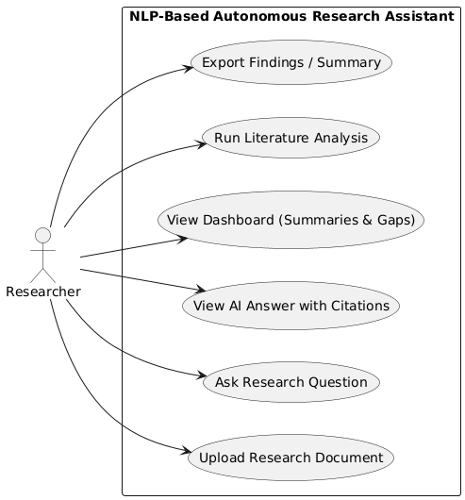

Fig 4.1.1 Use Case Diagram

4.1.2 Activity Diagram
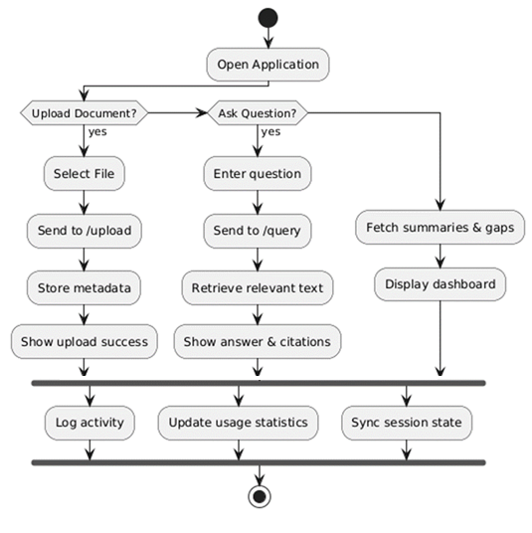
The Activity Diagram shows the overall workflow of the system as a series of activities. It starts from document upload, moves through text extraction, chunking, embedding generation, retrieval, reasoning, and ends with output delivery. The diagram visualizes decision points and parallel tasks. It helps explain the logical flow and operational sequencing of the system.
Fig 4.1.2 Activity Diagram

4.1.3 Sequence Diagram
The Sequence Diagram illustrates the step-by-step interaction between the user and different components of the system during a research query. It shows how the user sends a request, how the frontend communicates with the backend, and how the backend retrieves embeddings from the vector database. The diagram also highlights how the LLM processes the retrieved context and generates a final answer. This representation helps visualize the order of operations and the flow of information in the system.
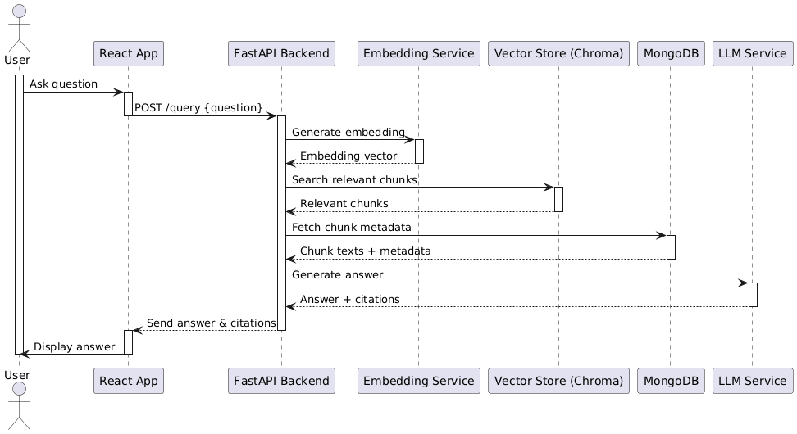
Fig 4.1.3 Sequence Diagram

4.1.4 Class Diagram
The Class Diagram represents the core structure of the system by showing classes such as User, Document, Chunk, Embedding, VectorDB, and LLM. Each class contains attributes and methods that define its behavior. The relationships between classes illustrate how data flows internally. This diagram provides a blueprint of the system’s architecture and object relationships.
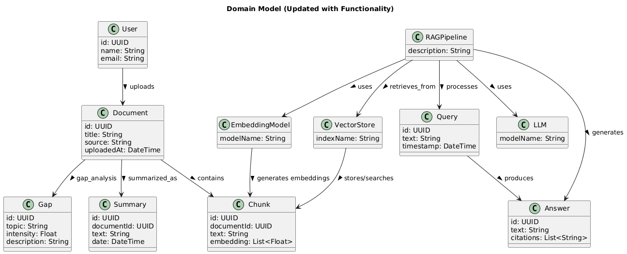
Fig 4.1.3 Class Diagram

4.1.5 Component Diagram
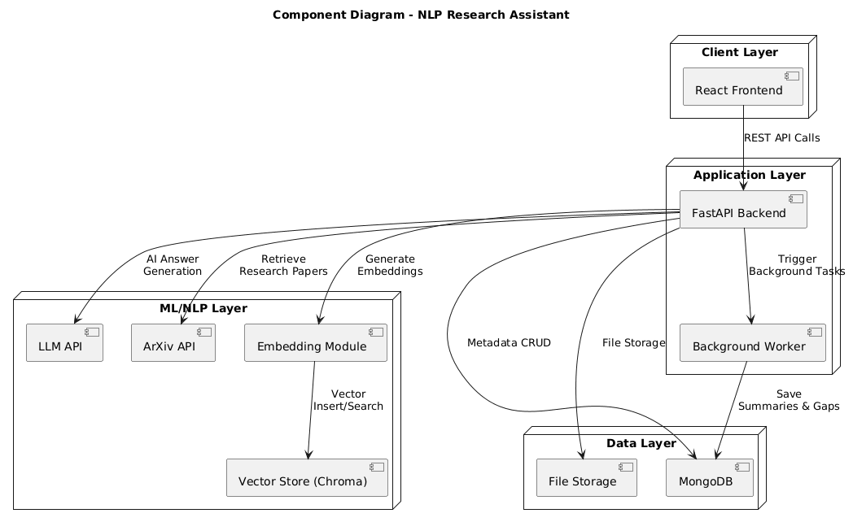
The Component Diagram shows how the entire system is divided into independent functional modules such as the Frontend, Backend API, NLP Processor, Vector Database, and LLM Engine. Each component handles a specific part of the workflow and communicates with others through well-defined interfaces and APIs. It highlights how the system is modular, scalable, and easy to maintain. This diagram helps visualize the high-level structure of the application and how major components interact to deliver the final output.

Fig 4.1.5 Component Diagram

4.1.6 Deployment Diagram
The Deployment Diagram illustrates how the system’s software components are distributed across physical or virtual hardware nodes. It shows the frontend hosted on a client machine or browser, the backend running on a server environment, and the vector database and LLM engine deployed on separate compute nodes or cloud services. This diagram helps visualize execution environments, communication paths, and how the system operates in real deployment conditions. It also highlights the system’s scalability and infrastructure requirements.
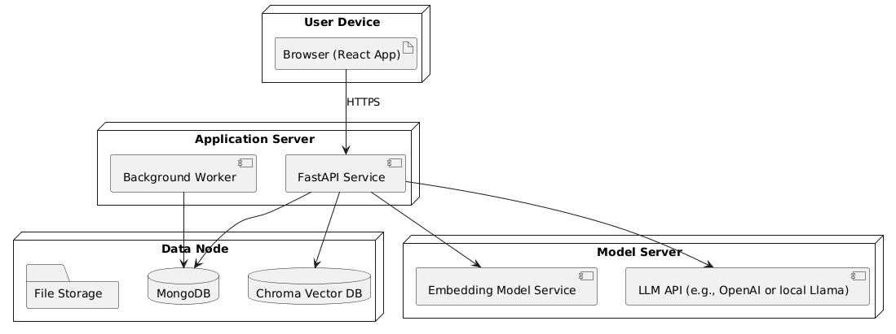
Fig 4.1.6 Deployment Diagram

4.1.7 Communication Diagram
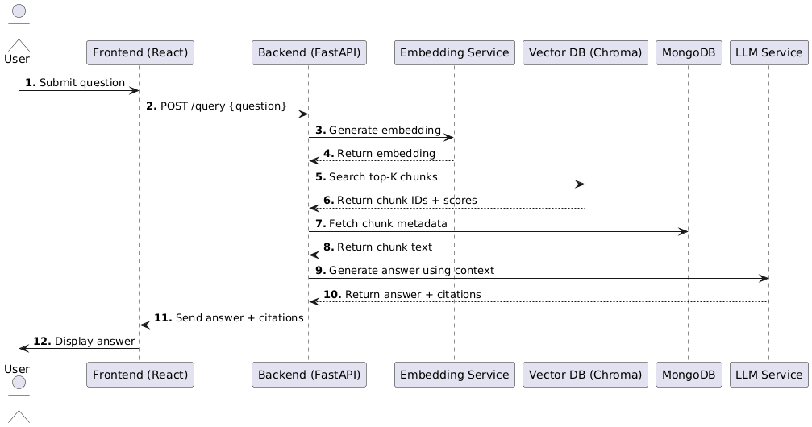
The Communication Diagram shows how different system components exchange messages to complete a task. It highlights the interactions between the user interface, backend API, vector database, and the LLM by focusing on message flow rather than timing. Each component is represented as an object, and the numbered messages show how they collaborate to process queries and generate responses. This diagram helps visualize how responsibilities are shared and how components coordinate to deliver results.

Fig 4.1.7 Communication Diagram

4.1.8 Object Diagram
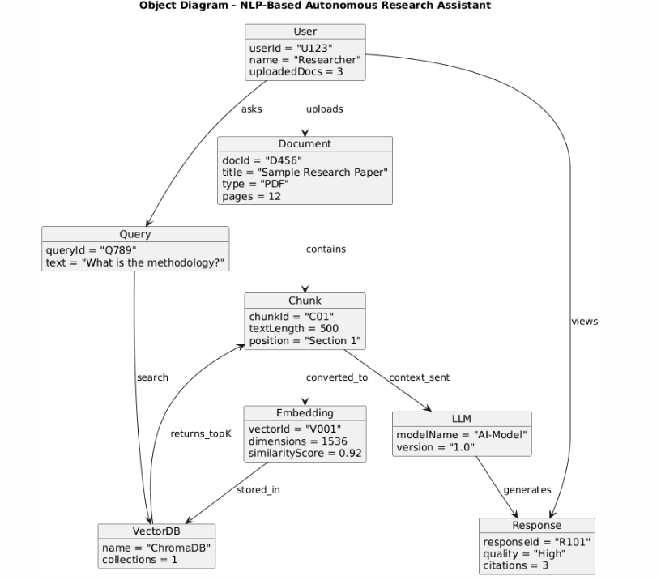
The Object Diagram provides a snapshot of system objects at a specific moment during execution. It shows concrete instances such as a specific Document, Chunk, Embedding, and Response, along with their current values. This diagram helps visualize how the system looks during runtime with real data. It also shows the associations between live objects during processing.

Fig 4.1.8 Object Diagram

CHAPTER 5
PROPOSED WORK MODEL
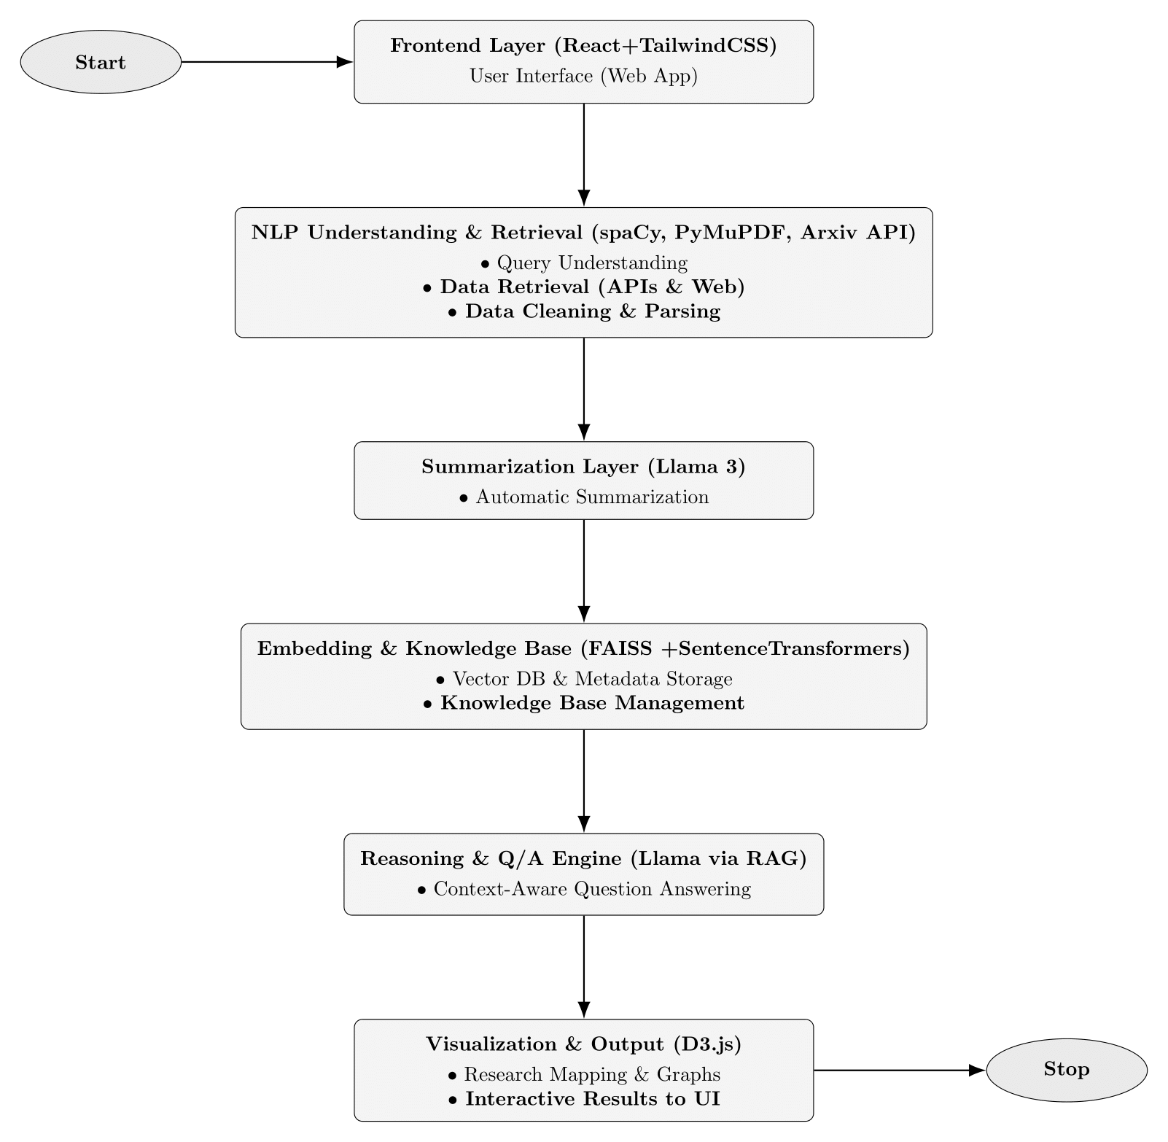
Fig 5.1 Proposed Work Model
The proposed work model for the NLP-Based Autonomous Research Assistant describes the full operational workflow of the system, starting from the moment the user interacts with the interface to the final stage where meaningful insights, summaries, and answers are delivered. The goal of this model is to create a seamless and automated research pipeline that reduces the manual effort required in traditional literature review and academic analysis. Each stage of the model has been designed to function as an independent module while maintaining smooth communication with other components, ensuring both scalability and efficiency.
The model is composed of five major layers that collaborate to process documents, understand user queries, retrieve relevant content, generate summaries, create embeddings, store knowledge, and finally produce visual and interactive outputs. This layered structure reflects a logical and organized approach to handling complex academic content, ensuring that users receive high-quality and contextually accurate results.
The workflow begins at the user interface, proceeds through natural language processing and summarization stages, passes into embedding and knowledge storage, and ultimately ends in reasoning, question answering, and visualization. The following sections explain each component of the proposed model in a detailed and structured manner.

5.1 Frontend Layer (React + TailwindCSS)
The system starts with the Frontend Layer, which acts as the bridge between the user and the research assistant. This layer is built using React for component-based UI development and TailwindCSS for modern, responsive styling. The frontend enables users to upload research papers, type questions, view summaries, explore visualizations, and access retrieved information.
The design of the interface focuses on simplicity and ease of use. Instead of presenting users with complicated workflows, the frontend provides clear options and interactive elements. Document uploads, query inputs, and result displays are handled smoothly using asynchronous API calls. The frontend does not perform computational tasks but serves as the front-facing portal through which all user actions are initiated. Its function is crucial because an intuitive interface significantly enhances user engagement and productivity.

5.2 NLP Understanding and Retrieval Layer
Once the user uploads a document or submits a query, the request moves into the NLP Understanding and Retrieval Layer. This layer focuses on extracting meaningful text, preparing the content, and understanding user intent. It relies on tools such as spaCy, PyMuPDF, and other parsing libraries to extract and clean the textual data from PDFs and other formats.
The raw text obtained from research papers often contains headers, footers, formulas, diagrams, and unnecessary symbols. Therefore, data cleaning and normalization are performed to refine the text into a readable and processable structure. This layer also handles entity recognition, sentence segmentation, and removal of noise.
In addition to document-level processing, this layer also interprets user queries. Understanding what the user is looking for enables the system to retrieve the most relevant segments from the knowledge base. If needed, the system can reach external APIs or datasets to supplement missing information. The primary objective of this layer is to prepare all inputs into a clean, structured form so that the later modules can work effectively.

5.3 Summarization Layer
After text is cleaned and organized, it enters the Summarization Layer. This module is responsible for generating concise summaries that capture the essence of large research papers. Summarization is essential because academic papers often contain lengthy explanations and technical details that may overwhelm users who only need the key contributions or methodology.
The summarization model, such as Llama-3 or any transformer-based summarizer, processes the cleaned text and produces human-readable summaries. These summaries enable users to understand the primary objectives, techniques, results, and findings of the document without reading the entire paper. Automatic summarization also allows the system to categorize documents, detect themes, and identify important concepts.
This layer is particularly helpful for beginners who are unfamiliar with complex research language. It reduces cognitive load and speeds up comprehension. It also serves as a foundation for later stages where the question answering system may rely on summarized content as contextual support.

5.4 Embedding and Knowledge Base Layer
After summarization, the text is segmented into smaller chunks and converted into high-dimensional vector embeddings. This transformation is performed using models like SentenceTransformers. Embeddings are numerical representations that capture semantic meaning rather than surface-level keywords, which allows the system to perform advanced semantic search.
The generated embeddings are stored along with metadata in a vector database such as FAISS or Chroma. The knowledge base serves as the memory of the assistant, enabling it to retrieve information that is semantically similar to a user’s query. Instead of scanning the entire text each time, the system performs a similarity search using vector comparison to retrieve the most relevant chunks.
The knowledge base layer ensures efficient indexing, rapid retrieval, and scalable storage. As more documents are uploaded, the vector database can grow dynamically without affecting performance. This layer gives the system its ability to understand academic content on a deeper level and respond with contextually accurate information.

5.5 Reasoning and Question Answering Engine
When the user asks a research question, the query is converted into an embedding and compared with stored vectors to retrieve relevant information. The retrieved text chunks are passed to the language model through a Retrieval-Augmented Generation (RAG) pipeline. This ensures that the final answer generated by the model is grounded in real content from the uploaded documents.
The reasoning engine interprets the retrieved information, analyzes it, and formulates a clear and coherent answer that directly addresses the user’s question. By combining retrieval and reasoning, the system avoids hallucination and ensures factual correctness. The question answering system can provide explanations, methodologies, comparisons, definitions, and even reference citations when applicable.
This layer is responsible for the “intelligence” of the research assistant. It processes the context, understands relationships between concepts, and provides meaningful insights that would typically require a human researcher to manually read through multiple papers.

5.6 Visualization and Output Layer
The final stage of the proposed work model involves generating visual and interactive outputs. Using tools such as D3.js, the system can create research maps, graphs, citation visualizations, keyword networks, and other interactive elements that help users understand the structure and content of the papers.
Visualization is an essential component because raw text is often insufficient for understanding complex patterns in research. Graphical representations allow users to see topic distributions, important keywords, document relationships, and gaps in the literature. The processed results, including summaries, answers, and graphs, are then returned to the frontend interface for user interaction.
The Visualization and Output Layer completes the pipeline by transforming processed data into easily interpretable information that supports decision-making, research direction, and academic understanding.

5.7 Summary of the Proposed Model
The proposed work model integrates modern NLP techniques, deep learning, vector search, and interactive visualization to create a comprehensive research assistant. The layered design ensures modularity, scalability, and efficient processing at each stage of the workflow. By automating document handling, summarization, embedding generation, retrieval, reasoning, and visualization, the system significantly reduces manual workload and supports users in navigating large volumes of academic content with ease.
This model forms the foundation of the system’s overall architecture and reflects how advanced AI technologies can be combined to create a powerful tool for academic research and knowledge discovery.

CHAPTER 6
SCREENSHOTS

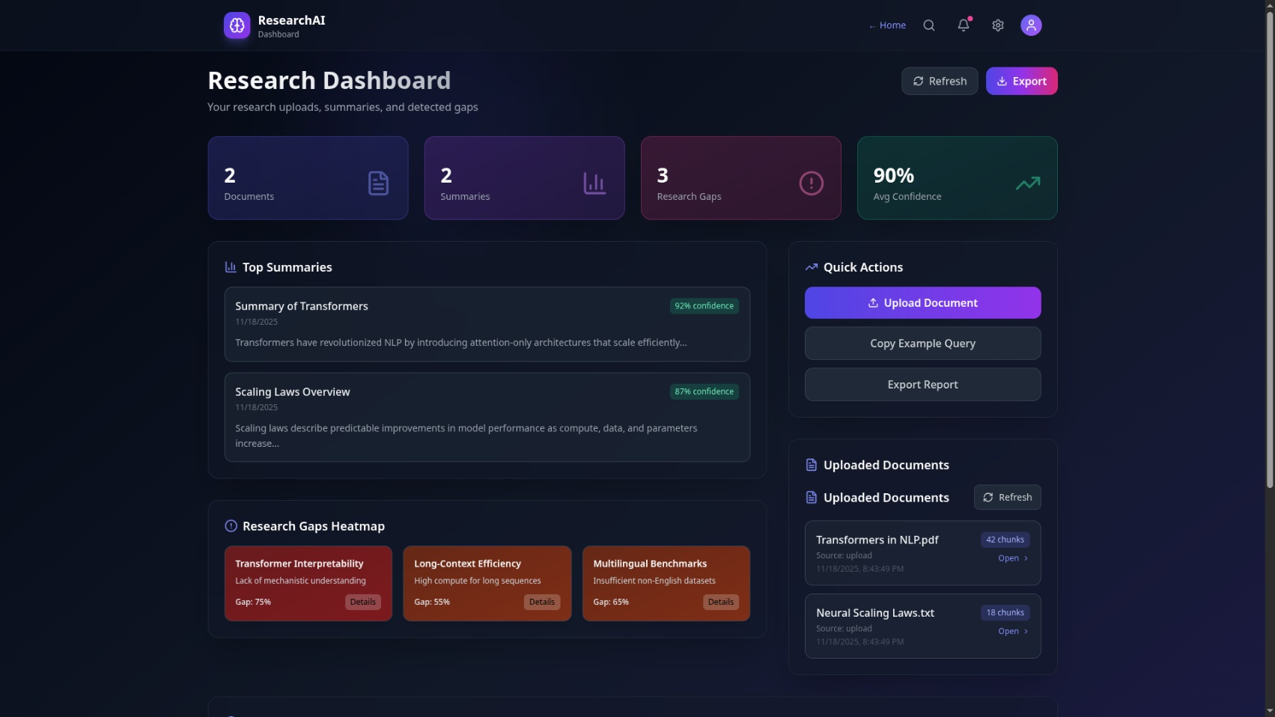
Fig6.1 : Dashboard

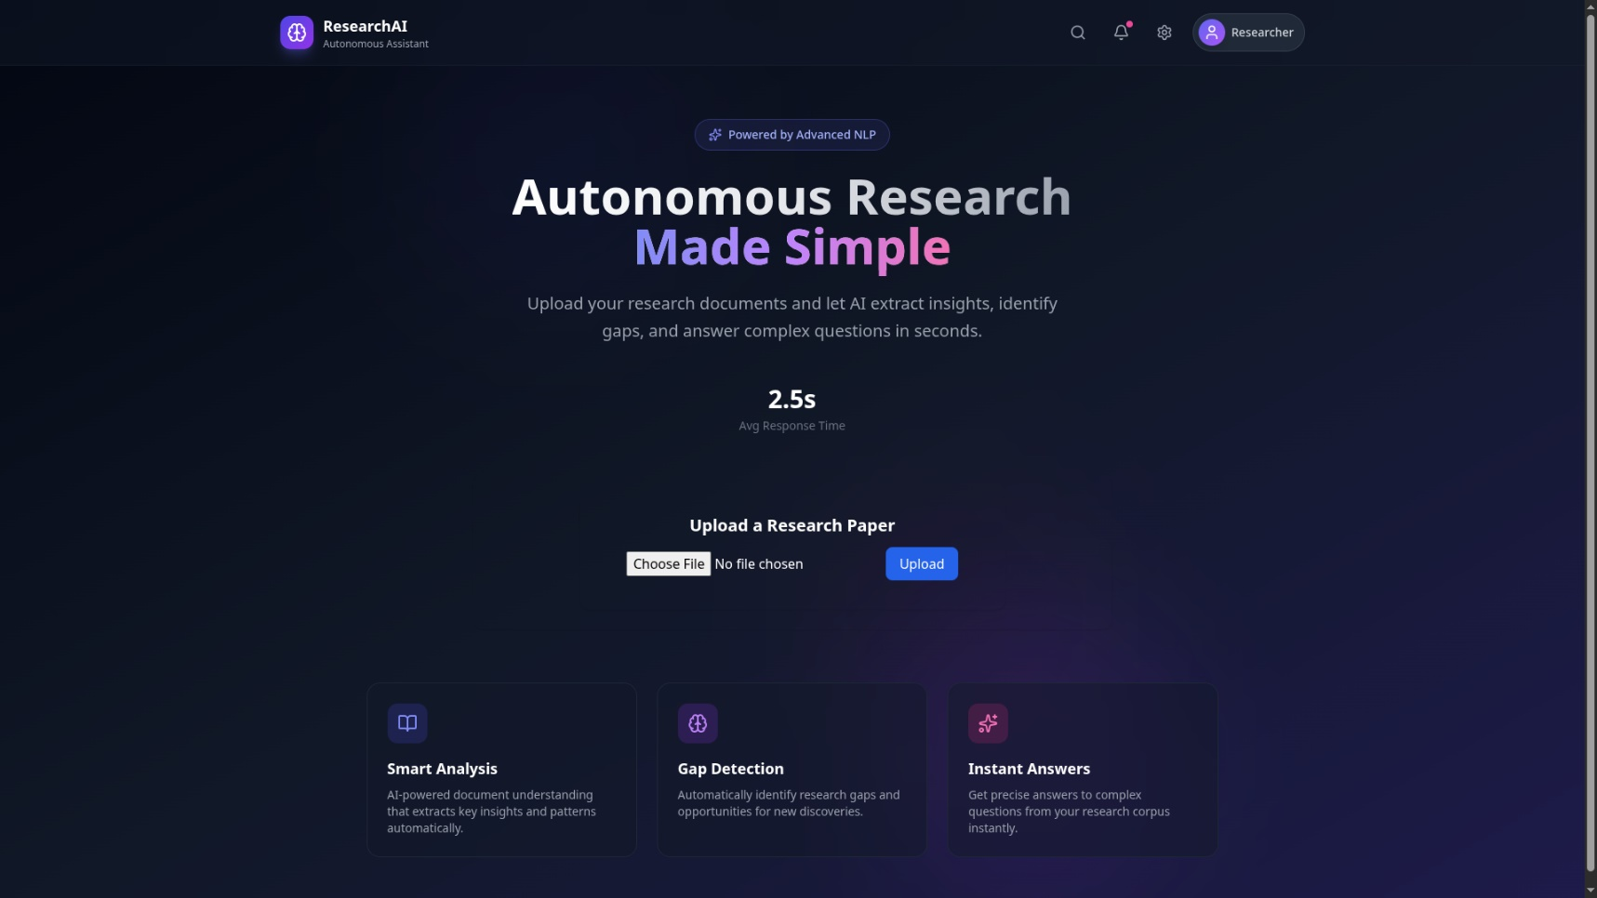
Fig6.2 : HomePage

CHAPTER 7
TECHNOLOGY STACK
The technology stack of the NLP-Based Autonomous Research Assistant plays a crucial role in ensuring the system’s performance, scalability, security, and accuracy. Because the system integrates multiple layers of processing—ranging from document parsing to semantic retrieval and AI-driven reasoning—it relies on a diverse set of modern technologies. Each technology has been selected carefully based on its reliability, speed, ease of integration, and suitability for research automation tasks. This chapter presents a comprehensive explanation of all major tools, frameworks, libraries, and platforms used in the development of the system. The stack is divided into frontend technologies, backend technologies, NLP and AI frameworks, vector storage components, databases, deployment tools, and additional utilities that support the system.

Frontend Technologies
The frontend of the system is responsible for providing a clean, intuitive, and responsive user interface through which users can upload files, interact with the application, view summaries, ask questions, and explore visualizations. A well-structured frontend enhances usability and ensures that complex functionalities are presented in a simple manner.

React.js
React is the primary framework used for building the web interface. It is a component-based library that enables developers to create reusable UI components. React’s virtual DOM makes it efficient for building dynamic applications where elements need to update frequently, such as displaying query results, processing status, graphs, and summaries. Its ecosystem, large community support, and flexibility make it an ideal choice for a modern research assistant interface.

TailwindCSS
TailwindCSS is used to style the frontend. It provides utility-first classes that allow rapid UI development without writing long CSS files. Tailwind ensures a clean and professional appearance while giving full control over spacing, alignment, colors, and typography. Because the application requires a minimalistic yet functional interface, TailwindCSS fits perfectly.

Axios
Axios is used for making HTTP requests from the frontend to the backend API. It supports file uploads, query submissions, and retrieval of processed outputs. It provides an easy-to-handle promise-based syntax and consistent error handling, making it essential for smooth frontend-backend communication.

D3.js
D3.js is included for data visualizations. It is a powerful JavaScript library capable of producing dynamic graphs, charts, network diagrams, and interactive research maps. The system uses D3.js to visually represent extracted keywords, topic clusters, citation networks, and document relationships, helping users understand academic content through visualization.

Backend Technologies
The backend acts as the core engine of the system. It manages processing tasks, handles API calls, performs computations, interacts with the vector database, communicates with the language model, and orchestrates the entire workflow.

FastAPI
FastAPI is the backend framework used for building RESTful APIs. It is selected because of its high performance, automatic documentation via Swagger UI, support for asynchronous operations, and easy integration with machine learning components. FastAPI ensures low latency and fast responses even when handling heavy workloads such as document chunking, embeddings generation, or LLM inference requests. Its syntax is clean, and its modular structure aligns well with the layered architecture of this research assistant.

Python 3.x
Python is the primary language used across backend modules. Its extensive library ecosystem for NLP, machine learning, and data processing makes it the ideal choice. Python’s readability and versatility ensure that different components of the system can be developed and integrated seamlessly.

Uvicorn / Gunicorn
These high-performance ASGI servers are used to run the FastAPI application. Uvicorn is lightweight and fast, making it suitable for API endpoints that require quick responses. Gunicorn can be used for multi-worker setups when scaling the backend.

Natural Language Processing (NLP) Technologies
NLP technologies form the core intelligence of the system. They help process raw academic text, understand user queries, extract meaningful insights, and support reasoning tasks.

spaCy
spaCy is used for text preprocessing, tokenization, sentence segmentation, named entity recognition, and cleaning. It is fast, reliable, and suitable for large-scale text processing, making it appropriate for handling lengthy research papers.

PyMuPDF
PyMuPDF (also known as fitz) is a Python library used to extract text from PDF documents. Research documents often contain equations, tables, diagrams, and varying formatting. PyMuPDF provides robust extraction capabilities that preserve structure better than many other libraries.

SentenceTransformers
This framework provides pre-trained models that convert text chunks into vector embeddings. These embeddings are essential for semantic search. The framework supports multiple transformer architectures and offers fast inference, enabling efficient storage and retrieval of academic content.

Transformers Library
The Hugging Face Transformers library supports integration with various models such as Llama, T5, BERT, GPT-based architectures, and summarization models. It allows the system to perform tasks like summarization, embedding generation, question answering, and classification by leveraging state-of-the-art pre-trained models.

Large Language Model (LLM) Technologies
The system relies on advanced language models to generate context-aware answers, produce summaries, and support reasoning tasks.

Llama (via RAG Pipeline)
Llama (or similar models such as GPT-based architectures) is used for generating answers grounded in the retrieved context. The model is integrated through a Retrieval-Augmented Generation pipeline, ensuring that outputs are accurate, factual, and based on the uploaded documents. Llama excels in tasks involving reasoning, paraphrasing, summarization, and citation-based explanations.

RAG (Retrieval-Augmented Generation)
RAG combines retrieval with generation. Instead of relying solely on the model’s pre-trained knowledge, the system retrieves relevant document chunks from the vector store and provides them as context. This minimizes hallucination and ensures that the system's responses are verifiable and grounded in the actual research papers.

Vector Database and Semantic Search Technologies
Semantic retrieval is a central component of the research assistant. Instead of performing keyword matching, the system uses high-dimensional embeddings stored in vector databases to identify the most relevant segments of text.

FAISS
FAISS (Facebook AI Similarity Search) is a vector search library designed for efficient similarity search over large datasets. It supports GPU acceleration and optimized indexing, allowing extremely fast top-K searches. FAISS is ideal for research-heavy use cases where large amounts of document embeddings must be retrieved quickly.

ChromaDB
ChromaDB is used as a simpler, developer-friendly vector storage solution. It integrates easily with Python and supports metadata storage. ChromaDB enables embedding storage, indexing, and retrieval, making it suitable for smaller-scale deployments or local development.

Similarity Metrics
Cosine similarity, dot product, and Euclidean distance are used to score the similarity between query embeddings and document embeddings. These metrics are fundamental to retrieving the most contextually relevant chunks from the knowledge base.

Metadata and Document Storage
Metadata storage is essential for managing document information, chunk positions, timestamps, file sources, and user details.

MongoDB
MongoDB is used for storing metadata associated with the uploaded documents. Its document-oriented structure makes it easy to store flexible schemas such as chunk references, citation details, or user history. It scales well and supports quick read-write operations, which is important when handling multiple user uploads and complex document structures.

Local or Cloud File Storage
Uploaded PDFs or research papers are stored in a file storage system. This could be local storage during development or cloud storage (AWS S3, Google Cloud Storage) in a production environment.

Visualization Technologies
Visual representation of research insights helps users understand complex relationships and patterns that may not be visible through text alone.

D3.js
D3.js enables the system to generate dynamic, interactive visualizations such as keyword graphs, cluster maps, citation networks, and timeline charts. These visualizations enhance user comprehension and provide a richer research experience.

Chart.js / Recharts (optional)
These libraries can be used alongside D3.js to display simpler charts such as bar charts, pie charts, and trend graphs for basic data visualization needs.

Deployment and DevOps Technologies
To ensure reliable performance, the system can be deployed using modern containerization and DevOps tools.

Docker
Docker allows the system’s backend, LLM engine, and vector database to run inside isolated containers. This ensures consistency across development and deployment environments.

Nginx
Nginx can be used as a reverse proxy to route requests, enable HTTPS, and handle load balancing when scaling the system.

Cloud Platforms
Depending on deployment need, the system can run on:
- AWS EC2 or ECS
- Google Cloud Run or Kubernetes Engine
- Azure Container Instances
Cloud platforms provide scalability to handle more users, larger documents, and heavier workloads.

upporting Libraries and Utilities
A number of additional libraries support the system’s operations:

NumPy and Pandas
Used for mathematical operations, array manipulation, and basic data processing.

Pydantic
Used in FastAPI to define structured request and response models.

Logging Frameworks
Python’s logging module is used to track errors, performance metrics, and system behavior during execution.

JWT or OAuth
Used for handling authentication and session management if the system supports multiple users.

Summary of Technology Stack
The technology stack chosen for this system combines modern web development frameworks, fast backend processing tools, advanced NLP platforms, efficient vector storage technologies, and scalable deployment options. Each technology contributes to a specific part of the workflow, and together they form a powerful architecture capable of automating research tasks, generating insights, answering questions, and aiding researchers in understanding complex academic documents.
The combination of React, FastAPI, Llama models, FAISS or Chroma, MongoDB, and visualization tools makes the system robust, flexible, and future-proof. This stack ensures that the assistant can process large volumes of text, retrieve context accurately.

CHAPTER 8
FUTURE WORK
The NLP-Based Autonomous Research Assistant presented in this project establishes a strong foundation for automating research workflows, enabling users to upload documents, extract summaries, generate embeddings, retrieve relevant information, and obtain context-grounded answers. While the system delivers substantial functionality in its current state, there remains considerable scope for enhancement, expansion, and optimization. Future improvements can significantly elevate the system’s intelligence, accuracy, scalability, and usability. This chapter outlines potential directions for future work, exploring technical enhancements, user experience improvements, advanced features, integration possibilities, and long-term research opportunities.
The future work of this system can be categorized into several major areas, including improvements in natural language understanding, expansion of the knowledge base, advanced reasoning capabilities, enhanced visualization tools, multi-document research automation, cross-domain adaptability, large-scale deployment, and the integration of emerging AI models and tools. These enhancements will help evolve the system into a more autonomous, comprehensive, and researcher-friendly platform capable of supporting advanced academic analysis.

Advanced Summarization and Context Understanding
Although the current system provides high-quality summaries using transformer-based models, future versions can incorporate more sophisticated summarization techniques. Multi-document summarization can be introduced so that the system can evaluate hundreds of related papers and generate consolidated summaries that reflect overall trends in the research field. This is especially useful for users preparing literature reviews or survey papers.
Additionally, the system could adopt abstractive summarization models that are specifically fine-tuned for academic writing. These models would be capable of generating domain-aware summaries that understand complex terminologies and capture the essence of research contributions. Context-aware summarization can also be introduced, allowing users to request summaries focused on particular sections such as methodology, results, conclusions, or limitations.
There is also potential for dynamic summarization, where users can specify the length, depth, or focus of the generated summary. For example, the system could produce a 5-line summary for quick understanding, a one-page summary for presentation preparation, or a detailed multi-page summary for academic writing. Such flexibility would enhance the system’s usefulness across different scenarios.

Integration of Domain-Specific Models
Currently, the system uses general-purpose language models. In the future, specialized models tailored for specific academic fields such as medicine, engineering, law, economics, or environmental science can be integrated. These domain-specific models provide improved accuracy because they are trained on terminology, structures, and writing patterns unique to each field.
By enabling field selection during document upload, users can benefit from more precise interpretations, summaries, and answers. For instance, a medical model can understand clinical terminologies and diagnoses, while an engineering model can comprehend technical specifications and algorithms. Such specialization would make the research assistant highly effective for advanced researchers and professionals working in niche domains.

Multi-Document Analysis and Automated Literature Surveys
One of the most impactful future enhancements is the addition of multi-document analysis. Instead of processing documents individually, the system can analyze hundreds of papers simultaneously to identify recurring themes, common methodologies, statistical trends, and emerging research directions. This capability would reduce the time needed for literature reviews from weeks to minutes.
The system could automatically cluster related documents based on similarity, detect influential works through citation patterns, and identify gaps in the existing knowledge. Once these insights are extracted, the system can automatically generate literature survey drafts that include consolidated summaries, comparisons of methods, evaluation of datasets, and organized theme-based insights.
Automated literature surveys will significantly reduce manual effort for students preparing dissertations or researchers drafting review papers. This feature can also help identify the most influential papers and provide recommendations for further reading.

Enhanced Research Gap Detection
Currently, the system can highlight missing or less-explored areas within a single document. Future versions can enhance gap detection through multi-document comparative analysis, topic modeling, and cluster deviation techniques. With advanced algorithms, the system could analyze gaps across an entire field, highlight areas with limited prior work, and suggest potential research questions that could be explored further.
For example, the assistant could examine multiple documents and determine that certain datasets, populations, techniques, or evaluation metrics are underused. It could also detect contradicting findings across papers and highlight unresolved debates in the literature. Improved gap detection would assist researchers in identifying meaningful, relevant and novelty-oriented topics for projects, theses, and research proposals.

Improved Vector Database and Retrieval Optimization
Future enhancements could introduce more advanced vector search techniques such as hierarchical navigable small world graphs (HNSW), IVF indexes, or optimized distributed vector retrieval architectures. These techniques enable the system to store millions of embeddings and retrieve results faster and more accurately.
A hybrid retrieval approach combining sparse search (BM25) and dense retrieval (embeddings) could also be integrated to improve relevance. This ensures that documents that match keywords, even if not semantically close, are still retrieved. The system could also incorporate relevance feedback mechanisms where users can mark retrieved chunks as useful or irrelevant, allowing the system to continuously improve its retrieval accuracy over time.

Improved Reasoning and Long-Context LLM Integration
Future versions of the system could adopt long-context models capable of processing hundreds of pages without chunking. Current LLMs often have token limits, requiring long documents to be split into smaller fragments. Long-context models solve this by enabling direct processing of entire documents, resulting in more accurate summaries, improved question answering, and deeper contextual reasoning.
Additionally, advanced reasoning models such as chain-of-thought enhanced LLMs, self-correcting models, or agentic AI frameworks could be integrated to enable multi-step reasoning, hypothesis testing, and deeper analysis. This could allow the assistant to compare methodologies, critique studies, infer implications, and even simulate peer-review style feedback.

Voice-Based Research Assistance
To increase accessibility, future versions could include voice-based interaction. Users would be able to ask questions, request summaries, or command analysis through voice input. This is beneficial for individuals with reading difficulties, visual impairments, or researchers who prefer hands-free interaction.
Additionally, the system could read summaries aloud, explain complex sections, or offer audio-based interpretations of scientific diagrams. Integrating text-to-speech and speech-to-text models would expand the platform’s usability across a broader audience.

Integration with Academic Databases and APIs
To enrich the system’s capabilities, it could be integrated with academic APIs such as arXiv, PubMed, IEEE Xplore, ACM Digital Library, and Google Scholar. This would enable automatic fetching of research papers, metadata, abstracts, citations, and references. With this feature, users could initiate a search query, and the system would download relevant papers in real-time for analysis.
Such integration would transform the assistant into a complete research retrieval platform in addition to a reasoning system. It could also track citation histories, identify trending topics, and provide updates whenever new research is published in the user’s area of interest.

Collaboration and Multi-User Features
Future enhancements may include multi-user support, enabling collaboration among teams, research groups, or academic institutions. Users could share documents, organize joint literature reviews, assign tags, create shared notes, and build collective knowledge graphs. These collaborative features would make the system suitable for university labs, research groups, and corporate teams.
Features could include shared dashboards, comment threads, document annotations, and version tracking. Integration with cloud storage platforms such as Google Drive or Microsoft OneDrive would further support collaborative workflows.

Advanced Visualization and Analytics Tools
Visualization tools can be expanded to include deeper analytics such as keyword frequency graphs, author influence maps, research topic evolution timelines, citation network graphs, and semantic clusters. These visualizations can help researchers quickly understand trends and relationships in their field.
Future versions could integrate AI-based visualization techniques that automatically generate infographics or visual explanations of complex studies. By providing interactive filtering, zooming, and drill-down features, the assistant could become a powerful academic exploration tool.

Real-Time Recommendations and Personalization
The system can be enhanced to provide intelligent recommendations based on user behavior. By analyzing previous uploads, queries, and interests, the assistant could suggest research papers, summaries, topics, and potential research directions. Personalization algorithms can tailor results for each user, making the system more intuitive and efficient.
Additionally, researchers can receive alerts for new publications relevant to their work. This feature ensures that users stay up-to-date with the latest advancements in their research area.

Scaling and Deployment Enhancements
Future work could focus on deploying the system at scale. Cloud-native deployment using Kubernetes, serverless architectures, or distributed computing can enable the system to handle thousands of simultaneous users. Load balancing, auto-scaling, caching, and microservices can further optimize performance.
Security enhancements could include encrypted vector databases, secure authentication methods, access control, and compliance with data protection regulations, ensuring safe use in academic and enterprise environments.

Mobile Application Development
To increase accessibility, the system could be extended into a mobile application. Mobile support would enable researchers to upload documents, read summaries, and ask questions on the go. A dedicated mobile app could incorporate offline storage, push notifications, and mobile-friendly visualizations.

Educational and Institutional Integration
Future versions could be adapted for integration into universities, colleges, and research organizations. Institutions could use the system to facilitate coursework, guide project work, assist in thesis development, and support academic competitions. Integration with Learning Management Systems (LMS) such as Moodle or Canvas could make research education more interactive and AI-powered.

Ethical Considerations and Responsible AI
As the system evolves, reinforcing responsible AI practices will be essential. Future work should focus on reducing bias, improving fairness, and ensuring transparency in generated answers. Allowing users to view evidence sources for every response and offering explanations for model decisions would increase trust in the system. Moreover, future versions should incorporate rigorous evaluation metrics to ensure that generated insights are academically

CHAPTER 9
REFERENCE
- Vaswani, A. et al. Attention Is All You Need. NeurIPS, 2017.
- Devlin, J. et al. BERT: Pre-training of Deep Bidirectional Transformers for Language Understanding. 2018.
- Lewis, P. et al. Retrieval-Augmented Generation for Knowledge-Intensive NLP. Facebook AI, 2020.
- Reimers, N. & Gurevych, I. Sentence-BERT: Sentence Embeddings using Siamese BERT-Networks. 2019.
- Johnson, J. et al. FAISS: A Library for Efficient Similarity Search. Facebook AI, 2017.
- Wolf, T. et al. HuggingFace Transformers: State-of-the-art NLP library. 2020.
- ChromaDB Documentation. Vector Database for Embedding Storage and Retrieval.

